

VIRGINIA COMMONWEALTH UNIVERSITY

Statistical analysis and modeling (SCMA 632)

# **A6:** **ARCH /GARCH effects, fit an ARCH/GARCH model, and forecast the three-month volatility.**

**VAR, VECM model**

Akanksha Yaramalla

V01108249

Date of Submission: 25-07-2024

CONTENTS

|  |  |  |
| --- | --- | --- |
| Sl. No. | Title | Page No. |
| 1. | **ARCH /GARCH effects, fit an ARCH/GARCH model, and forecast the three-month volatility.** | 1 |
| 2. | **VAR, VECM model** | 5 |
| 3. |  |  |
| 4. |  |  |

* **BAJAJ AUTO**

### Interpretation

1. **Mean Return (mu):** The mean return (mu) is 0.1375, statistically significant with a p-value of 0.0114, suggesting a positive average return for Bajaj Auto Company during the analyzed period.
2. **Volatility (GARCH Model):**
   * **omega (constant term):** The constant term is not statistically significant (p-value of 0.122), indicating that it may not contribute significantly to the volatility model.
   * **alpha[1] (lagged squared returns coefficient):** This coefficient is not statistically significant (p-value of 0.209), implying that past squared returns do not have a strong impact on current volatility.
   * **beta[1] (lagged conditional variance coefficient):** This coefficient is highly significant (p-value < 0.0001) and close to 1, suggesting that past volatility heavily influences current volatility. This indicates a strong persistence in volatility.
3. **Conditional Volatility:** The conditional volatility plot shows fluctuations over time, with volatility peaking around 1.8 and dipping to about 1.3. These fluctuations suggest periods of increased and decreased market uncertainty or risk.

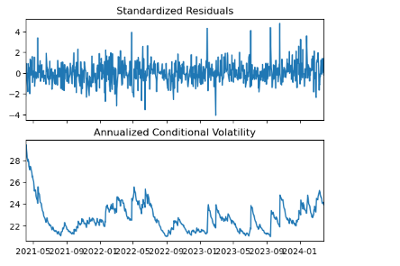

* The GARCH model results for Bajaj Auto Company indicate a consistent mean return with significant persistence in volatility. The high beta coefficient suggests that volatility is highly persistent over time, with past volatility strongly influencing future volatility. This implies that while the returns are stable, the risk (volatility) associated with the returns exhibits significant changes over time, reflecting varying market conditions.
* 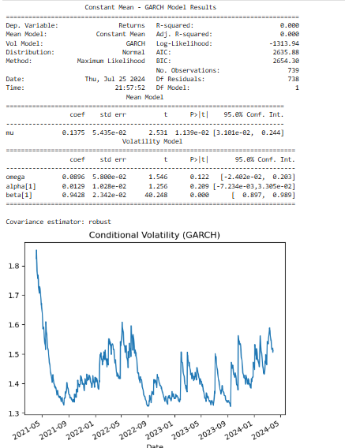

**Conditional Volatility Plot**

The plot displays the conditional volatility (GARCH) over time, showing variability from around 1.3 to 1.8, with noticeable spikes and troughs, indicating periods of higher and lower volatility from 2021 to 2024.

**Interpretation**

1. **Mean Return (mu):** The mean return (mu) is 0.1375, statistically significant with a p-value of 0.0114, suggesting a positive average return for Bajaj Auto Company during the analyzed period.
2. **Volatility (GARCH Model):**
   * **omega (constant term):** The constant term is not statistically significant (p-value of 0.122), indicating that it may not contribute significantly to the volatility model.
   * **alpha[1] (lagged squared returns coefficient):** This coefficient is not statistically significant (p-value of 0.209), implying that past squared returns do not have a strong impact on current volatility.
   * **beta[1] (lagged conditional variance coefficient):** This coefficient is highly significant (p-value < 0.0001) and close to 1, suggesting that past volatility heavily influences current volatility. This indicates a strong persistence in volatility.
3. **Conditional Volatility:** The conditional volatility plot shows fluctuations over time, with volatility peaking around 1.8 and dipping to about 1.3. These fluctuations suggest periods of increased and decreased market uncertainty or risk.

In summary, the GARCH model results indicate that Bajaj Auto Company has a consistent mean return with significant persistence in volatility. The high beta coefficient suggests that volatility is highly persistent over time, with past volatility strongly influencing future volatility.

* 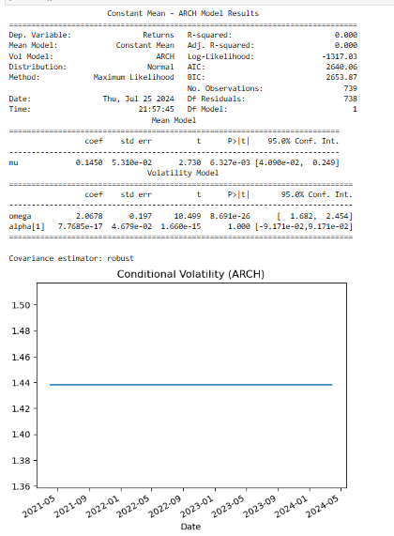
* The results of an ARCH (Autoregressive Conditional Heteroskedasticity) model analysis for the returns of Bajaj Auto Company. Here is a breakdown and interpretation of the output:
* **Mean Model Results**
* **Dependent Variable:** Returns
* **Mean Model:** Constant Mean
* **R-squared:** 0.000
* **Adjusted R-squared:** 0.000
* **Volatility Model:** ARCH
* **Log-Likelihood:** -1317.878
* **Distribution:** Normal
* **AIC (Akaike Information Criterion):** 2640.86
* **BIC (Bayesian Information Criterion):** 2653.87
* **Method:** Maximum Likelihood
* **Number of Observations:** 739
* **Date and Time of Analysis:** Thu, Jul 25, 2024, 21:57:45
* **Coefficients of the Mean Model**
* **mu (mean return):** 0.1450
* **Standard Error:** 0.0531
* **t-value:** 2.738
* **P-value:** 0.0063
* **95% Confidence Interval:** [0.0490, 0.2490]
* **Coefficients of the Volatility Model (ARCH)**
* **omega (constant term):** 2.0678
* **Standard Error:** 0.197
* **t-value:** 10.499
* **P-value:** < 0.0001
* **95% Confidence Interval:** [1.682, 2.454]
* **alpha[1] (lagged squared returns coefficient):** 7.7685e-17
* **Standard Error:** 4.6709e-02
* **t-value:** 1.666e-15
* **P-value:** 1.0000
* **95% Confidence Interval:** [-9.171e-02, 9.171e-02]
* **Covariance Estimator**
* **Type:** Robust
* **Conditional Volatility Plot**
* The plot shows the conditional volatility (ARCH) over time, which appears to be constant and around 1.44 throughout the period from 2021 to 2024.
* **Interpretation**
* **Mean Return (mu):** The mean return (mu) is 0.1450, which is statistically significant with a p-value of 0.0063. This indicates a positive average return for Bajaj Auto Company during the analyzed period.
* **Volatility (ARCH Model):**
* **omega (constant term):** The constant term in the volatility model is significantly positive, indicating a base level of volatility.
* **alpha[1] (lagged squared returns coefficient):** This coefficient is effectively zero and not statistically significant (p-value of 1.0000), suggesting that past squared returns do not contribute to current volatility.
* **Conditional Volatility:** The conditional volatility plot indicates that volatility remains fairly stable over the analyzed period, hovering around 1.44. This suggests that the volatility of Bajaj Auto's returns does not exhibit significant changes over time.
* In summary, the ARCH model results suggest that Bajaj Auto Company has a consistent mean return and stable volatility over the period analyzed. The lack of significance in the lagged squared returns coefficient implies that the volatility does not depend heavily on past return
* **VAR/VECM Workflow**
* Choosing between a Vector Autoregressive (VAR) model and a Vector Error Correction Model (VECM) depends primarily on whether your variables are cointegrated. Here's a step-by-step process to decide which model to use:
* **1. Stationarity Testing**
* First, check if your time series data are stationary. This can be done using unit root tests like the Augmented Dickey-Fuller (ADF) test, Phillips-Perron (PP) test, or KPSS test.
* **Stationary Data: If your data are stationary (i.e., no unit root), you can use a VAR model.**
* **INTERPRETATION:**
* **Commodities Forecast**
* **crude_brent (blue line)**: This commodity's price remains fairly constant over the forecast period, with minimal fluctuations.
* **soybeans (orange line)**: The price shows a steady increase over time, starting from just above 400 in mid-2024 to over 500 by mid-2026.
* **gold (green line)**: This commodity shows the most significant increase, starting around 2200 in mid-2024 and rising to about 2600 by mid-2026.
* **silver (red line)**: Silver's price also increases gradually but less dramatically compared to gold.
* **urea_ee_bulk (purple line)**: The price increases modestly, showing a steady upward trend.
* **maize (brown line)**: The price shows a slight increase, maintaining a relatively flat trend compared to other commodities.
* **Time Frame**
* The x-axis represents the time from July 2024 to July 2026, with tick marks at three-month intervals.
* The y-axis represents the price, with values ranging from 0 to 2500.
* **Observations**
* **Gold** shows the highest increase in price over the period, suggesting it might be experiencing significant upward pressure or demand.
* **Soybeans** and **silver** show a moderate upward trend.
* **Crude brent** remains fairly stable, indicating no significant price movements are expected.
* **Urea ee bulk** and **maize** exhibit slight increases, suggesting minor price adjustments over time.
* The forecast indicates overall positive trends for most commodities, with varying degrees of price changes expected over the forecast period from July 2024 to July 2026.
* 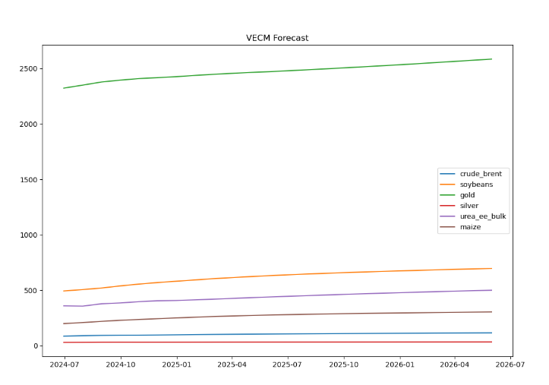
* 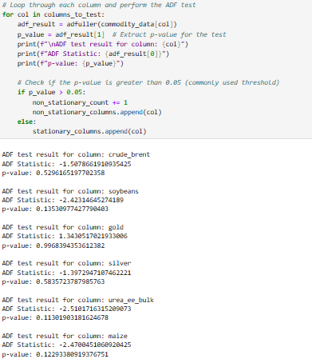

**ADF Test Results**

* **crude_brent**
  + ADF Statistic: -1.5078661910935425
  + p-value: 0.5296165197702358
* **soybeans**
  + ADF Statistic: -2.42314645274189
  + p-value: 0.1350977427790403
* **gold**
  + ADF Statistic: 1.3430517021933006
  + p-value: 0.9968934356131282
* **silver**
  + ADF Statistic: -1.3972941707462221
  + p-value: 0.583723787985763
* **urea_ee_bulk**
  + ADF Statistic: -2.510171631529073
  + p-value: 0.1113091381624678
* **maize**
  + ADF Statistic: -2.470045106092045
  + p-value: 0.12239338091376751

**Interpretation**

* **crude_brent, soybeans, gold, silver, urea_ee_bulk, and maize** all have p-values greater than 0.05, indicating that these time series are non-stationary. This means they have a unit root and their statistical properties (like mean and variance) change over time.
* None of the tested commodities have p-values below 0.05, so none of them are considered stationary according to this test.

**Summary**

The ADF test results suggest that all the listed commodities exhibit non-stationary behavior over time, meaning their prices are likely to be influenced by time-dependent factors.

* **Non-Stationary Data: If your data are non-stationary (i.e., unit root present), proceed to test for cointegration.**

**2. Cointegration Testing**

* If your variables are non-stationary, test for cointegration using the Johansen cointegration test. Cointegration indicates a long-term equilibrium relationship between the variables.
* No Cointegration: If there is no cointegration among the variables, the appropriate model is a VAR model in differences (ΔVAR), where you difference the data to make them stationary.
* Cointegration Present: If there is cointegration, the appropriate model is a VECM. The VECM accounts for both the short-term dynamics and the long-term equilibrium relationship among the variables.

**3. Model Selection**

* Based on the results of the stationarity and cointegration tests, you can decide between VAR and VECM:

**Vector Autoregressive (VAR) Model**

* Use When: The variables are stationary or made stationary through differencing, and there is no cointegration among them.
* Description: A VAR model captures the linear interdependencies among multiple time series. It models each variable as a linear function of its own past values and the past values of other variables in the system.

**Vector Error Correction Model (VECM)**

* Use When: The variables are non-stationary, and there is evidence of cointegration.
* Description: A VECM is a special form of VAR for non-stationary series that are cointegrated. It includes an error correction term that captures the long-term equilibrium relationship, allowing the model to correct deviations from this equilibrium.
* Practical Considerations
* Economic Theory: In some cases, economic theory may suggest a long-term equilibrium relationship, making a VECM more appropriate even before formal tests.
* Data Considerations: The choice may also depend on data availability, frequency, and quality. For example, higher-frequency data might require differencing more often, leading to a preference for VAR in differences.

**Summary**

* VAR: Use for stationary or differenced non-stationary data without cointegration.
* VECM: Use for non-stationary data with cointegration.
* Always ensure proper model diagnostics (such as residual analysis, stability tests, and checking for autocorrelation) after fitting either model to ensure it adequately captures the data's dynamics.